

FRIEDRICH-ALEXANDER
UNIVERSITÄT
ERLANGEN-NÜRNBERG
TECHNISCHE FAKULTÄT

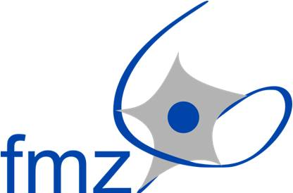


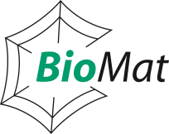


8th Scientific Seminar of the “North-Bavarian Biomaterials Alliance (NBBA)”

3rd November 2015, Hörsaal H31, Gebäude FAN-B, Universitätsstr. 30, 95440 Bayreuth, Germany
Welcome

16.00 h Dr. Martin Humenik

16.05 h Tamara Aigner (Department of Biomaterials, University of Bayreuth)
“Recombinant spider silk proteins for biomedical applications”

16.25 h Dr. Kiran Pawar (Department of Biomaterials, University of Bayreuth)
“Recombinant spider silk protein scaffolds for peripheral nerve repair”

16.45 h Prof. Aldo R. Boccaccini (Institute of Biomaterials, University of Erlangen-Nuremberg) (Department of Biomaterials, University of Bayreuth)
“Biofabrication research activities at the Erlangen Institute of Biomaterials“

17.05 h PD Dr. Andreas Arkudas (University Hospital Erlangen, University of Erlangen-Nuremberg)
“AV loop model for bone tissue engineering “

17.25 h Prof. Jürgen Groll (Department for Functional Materials in Medicine and Dentistry, University of Wuerzburg)
“FMZ beyond biofabrication “

17.45 h Prof. Robert Luxenhofer (Department for Chemical Technology and Material Synthesis, University of Wuerzburg)
“Novel thermoresponsive Hydrogels: First results on structure and biocompatibility”

18.05 h Concluding Remarks & Social hour, come together and discussions with beer and pretzels

Contact: Department of Biomaterials
Prof. Dr. rer. nat. Thomas Scheibel
Universitätsstr. 30, 95440 Bayreuth, Germany
Telefon +49 921 55-7361 - Telefax +49 921 55-7346
thomas.scheibel@uni-bayreuth.de
http://www.fiberlab.de/

